Ukie stand at gamescom 2024

Gamescom is the largest and most important business show for games in Europe. It is the place where developers, publishers, funders, service suppliers and the media gather to establish partnerships and cement relationships.

Ukie builds and manages a substantial UK stand at the heart of the business area. To be an exhibitor on the Ukie stand, please read the guide to the available packages and sponsorship below and then reserve your space by completing the online booking form here – https://zfrmz.com/VFo6jOLk5HoXlAKCz8fk

Q&A about the Ukie stand at gamescom

- Where and when will gamescom take place? Gamescom is hosted at the Kolnmesse in Cologne, Germany. The business halls, complete with the Ukie stand, will be open from Wednesday 21 August to Friday 23 August 2024
- What do I need to know about the Ukie stand? The Ukie stand is located in hall 3.2, stand number D20-F39 and has space for 100 UK exhibitors with dedicated tables, demo stations and meeting rooms available.
- Why should I book to be on the Ukie stand? The Ukie stand is a hugely popular destination at gamescom and a brilliant community of UK games companies. The stand dominates the hall and is easy to find. It also attracts substantial interest from passers-by. Economies of scale allow Ukie to keep the cost low and the support high with a fully managed reception area, marketing support, internet and drinks included in the packages. What’s more, Ukie does all the heavy lifting and stand build, so you don’t have to. All you need to do is turn up and start your meetings
- When do I need to book? As soon as possible! The stand space usually sells out by early July
- What is the cancellation policy? By booking on the official form you guarantee your space. Cancellation incurs a cost, starting at 50% of your order cost. If you cancel after 1 July you are liable for the entire booking cost.

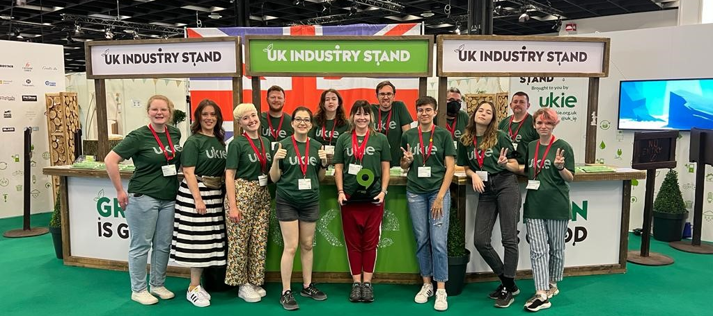

Any questions, please contact sam@ukie.org.uk / 07702 735050
Exhibitor packages for gamescom 2024

Please book your space using the online form here - https://zfrmz.com/VFo6jOLk5HoXlAKCz8fk

All exhibitor packages include the following benefits

- Dedicated space on the UK industry stand
- Fully managed reception area with meet and greet and waiting area for your clients
- Expo passes for your staff (quantity dependant on package)
- Listing on the gamescom website, access to the official gamescom and MeetToMatch business matchmaking systems
- Company promotion on marketing materials including the UK stand guide
- UK stand Wi-Fi
- Tea, coffee, water and snacks provided throughout the day

Package 1: Private meeting room on the UK industry stand

- Your own meeting room on the Ukie stand in the gamescom business area
- Choose your own meeting room size – starting from 2m x 3m
- Includes 4 chairs, 1 table, lockable door, power supply and company name on door
- Includes 4 exhibitor tickets for your staff
- 2 x Meet To Match accounts

Meeting room | Ukie member | Non-member
Private room (3m x 2m) | £7,500 | £8,500
Private room (3m x 3m) | £10,000 | £11,000
Other sizes on request

Package 2: Meeting table

- A dedicated table for your company within the shared open area on the UK industry stand
- Includes 4 chairs, table
- Includes 2 tickets for your staff
- 2 x Meet To Match accounts

Dedicated table | Ukie member | Non-member
Dedicated table | £3,500 | £4,300

Package 3: Demonstration station

- A demonstration station with power supply, TV, internet and game name card, located on the outside of the UK industry stand to attract passing traffic. You will need to bring your required console / laptop to showcase your games
- Includes 2 tickets for your staff
- 2 x Meet To Match accounts

Demonstration station | Ukie member | Non-member
Demonstration station | £4,000 | £4,700

For any questions, please contact sam@ukie.org.uk / 07702 735050
Package 4: Additional sponsorship opportunities

The Ukie stand is a great place to promote your brand and raise your profile to visitors and your fellow exhibitors. Ukie offers a range of additional items and sponsorship opportunities to help raise your brand.
If you have any ideas or items you would like to provide or sponsor please let me know.

All sponsorship items are ethically sourced and manufactured using recycled materials.

Item | Details | No. available | Unit cost
Advert in UK stand guide | A full-page advert in the UK stand newspaper (A4) | 12 | £300
Stand guide wraparound | 4 page full colour wraparound to stand guide | 1 | £1,200
Printing on a wall panel | A wall panel/door featuring your design (per panel) | 30 | £400
Expo passes | Additional expo passes |  | £100
Coffee & branded coffee cups | Sponsor of coffee and multiple use branded cups for every exhibitor and guests | 1 | £5,500
Breakfast pastries & fruit | Daily breakfast for the stand (3 days) | 1 | £2,750
Lunch sponsor | Sponsor the daily lunch (3 days) | 1 | £3,000
Branded ice cream | Your logo on the daily ice-cream delivery | 1 | £2,000
Sweet sponsors | Branding on the stand sweet shop | 1 | £2,500
Branded drinks coasters | Your branding on the reusable stand coasters | 1 | £2,500
Branded water bottles & watercoolers | Branded water bottles and signage at the coolers | 1 | £3,000
Branded lanyards | Company logo on the lanyards used by exhibitors | 1 | £2,000
Branded pencils | Recycled pencils with your message | 1 | £1,500
Sanitiser sponsor | Branded sanitiser station | 1 | £2,000
Face mask sponsor | Branded face masks | 1 | £2,500
Investment dinner sponsor | Sponsor and attend an international trade dinner with overseas investors (30 guests) | 2 | £4,000
UK Game of the Show | Sponsor the award for the best UK game on show | 1 | £3,000
UK stand drinks | Sponsor the end of day drinks on the stand (1 day) | 2 | £1,500

