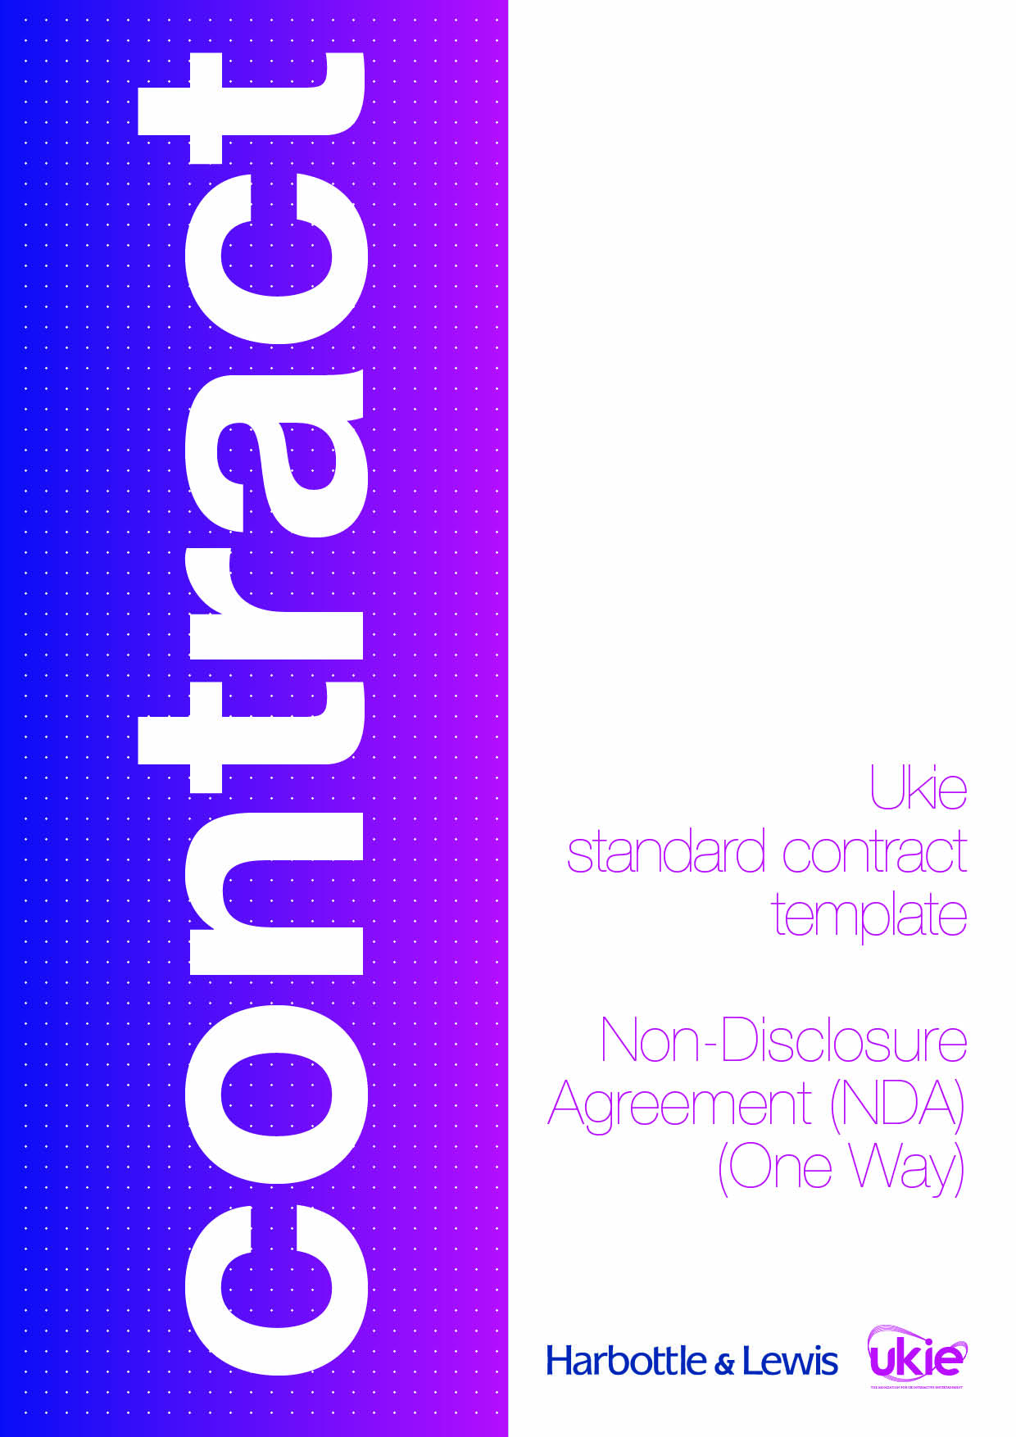



UKIE CONTRACT TEMPLATE
NON-DISCLOSURE AGREEMENT (ONE WAY)
IMPORTANT NOTES – PLEASE READ BEFORE USING THIS DOCUMENT
- This document has been prepared by Ukie Associate Member, Harbottle & Lewis. It is a basic non-disclosure agreement intended to be used as a starting-point by a company disclosing confidential information to another company in connection with a project.
- This document is designed to reasonably protect the party disclosing the confidential information without placing unfair or unreasonable obligations on the party receiving the information. If further protections for either party or a more tailored approach is required, you should seek legal advice.
- This document contains various yellow highlighted placeholders in square brackets, which will need to be completed before it can be issued.
- In addition to such placeholders, the definition of “Confidential Information” (see clause 1) should be reviewed (and, if necessary, amended) on each occasion before signature to ensure that it is appropriate and tailored to the particular information being disclosed.
- Entering into a non-disclosure agreement does not guarantee that the confidential information disclosed under it will be protected by the recipient party. If the recipient party uses or discloses such confidential information in breach of the agreement, it may be difficult for the disclosing party to seek a meaningful remedy. The disclosing party should therefore only disclose such confidential information as is absolutely necessary for the purposes of the project.
- This document has been prepared in light of the applicable English law as at June 2016 and will not reflect any subsequent changes to the law after such date.
- This document is intended to be used as a simple starting-point for a first draft of the document and does not constitute legal advice from Harbottle & Lewis LLP. You should seek legal advice if you intend to make any changes to the document. Please contact Alan Moss (alan.moss@harbottle.com) if you wish to discuss any aspect of the document.
THIS NON-DISCLOSURE AGREEMENT is entered into on 20[]

BETWEEN
(1) [INSERT COMPANY NAME], a company incorporated in England and Wales (company number: [INSERT NUMBER]) of [INSERT ADDRESS], email: [INSERT EMAIL ADDRESS] (Developer); and
(2) [INSERT COMPANY NAME], a company incorporated in England and Wales (company number: [INSERT NUMBER]) of [INSERT ADDRESS], email: [INSERT EMAIL ADDRESS] (Recipient).
WHEREAS
Developer wishes to disclose certain Confidential Information (as defined below) to Recipient in connection with [STATE THE PURPOSE, FOR EXAMPLE, THE EVALUATION OR ESTABLISHMENT OF A COLLABORATION IN RESPECT OF A PROJECT] (Purpose). The parties now wish to confirm the arrangements that have been agreed in connection with the disclosure of the Confidential Information.
IT IS AGREED as follows:
- Interpretation
  - Confidential Information means any and all information in any form or medium, including, without limitation:
    - any business information relating to Developer or its Group (or their respective employees, agents or other representatives) including, without limitation, any information relating to any plans, intentions, know how, intellectual property, operations, product information, customers, clients, suppliers, software or financial or business affairs;
    - the fact that discussions and negotiations are taking place concerning the Purpose and the status of those discussions and negotiations;
    - any information relating to the Purpose;
    - the existence and terms of this non-disclosure agreement (NDA); and
    - any information or analysis derived from any of the foregoing.
  - Group means each and any subsidiary or holding company from time to time of Developer and each and any subsidiary from time to time of a holding company of Developer and the terms “subsidiary” and “holding company” shall have the meaning given to such terms in section 1159 of the Companies Act 2006.
- Confidentiality
  - In consideration of Developer disclosing to Recipient Confidential Information, Recipient shall, subject to Clause 2.4, keep secret and confidential all Confidential Information that is disclosed to it or acquired or learned by it in connection with or pursuant to this NDA and acknowledges that all such Confidential Information shall be governed by the terms of this NDA without limit in time.
  - Recipient shall, with respect to any and all Confidential Information:
    - exercise a degree of care in preventing the unauthorised disclosure of such Confidential Information at least equal to the degree of care that it would exercise in respect of its own confidential information;
    - not copy, reproduce, distribute or disclose (subject to Clause 2.4) all or any part of such Confidential Information without Developer’s prior written consent;
    - procure that each person to whom any such Confidential Information is disclosed to the extent expressly permitted by this NDA shall specifically adhere to the terms of this NDA as if they were a party to it and shall accept any and all responsibility for such persons accordingly;
    - not remove or add any copyright, trade mark or other proprietary rights legend from any such Confidential Information unless specifically requested to do so by Developer in writing; and
    - not use or exploit any such Confidential Information in any way except for the Purpose.
  - The obligations set out in Clauses 2.1 and 2.2 above shall not apply to any information which:
    - is in the public domain other than as a consequence of a breach of the obligations in this NDA provided that any compilation of any information in the public domain that is in a form not publicly known shall nevertheless be treated as Confidential Information; and/or
    - Recipient can prove was in its possession prior to the date of this NDA and which was not received from Developer or any third party subject to an obligation of confidentiality or non-disclosure.
  - Recipient shall be entitled to disclose the Confidential Information to:
    - such of its employees, agents, representatives and professional advisers (Representatives) as have a need to know the same provided that Recipient shall:

procure that such Representatives adhere to the terms of this NDA as if they were a party to it; and

at all times remain primarily liable for any Representative’s failure to comply with the terms of this NDA; and/or
    - the extent required by law, an order of any court of competent jurisdiction or any other appropriate governmental or regulatory authority provided that, to the extent it is legally permitted to do so, Recipient shall promptly notify Developer in writing on becoming so required to disclose such Confidential Information.
- Ownership of the Confidential Information
  - With respect to any Confidential Information, all right, title and interest in and to such Confidential Information shall, subject to Recipient’s limited right to use such Confidential Information in accordance with Clause 2, remain with and vest in Developer and Recipient undertakes to do all such things and execute all such documents as may be required to give effect to the intention of this Clause.
  - Without prejudice to Clause 3.1, Recipient shall within 7 days of its receipt of a written request from Developer:
    - either:

deliver up; or

destroy,

all documentation, discs and/or other materials that include, contain, reflect or are based on the Confidential Information and any copies thereof (including, without limitation, any electronic copies); and
    - certify in writing to Developer that it has complied with the requirements of this Clause 3.2, provided that Recipient may:

retain documents and materials containing, reflecting, incorporating, or based on the Confidential Information to the extent required by law, an order of any court of competent jurisdiction or any other appropriate governmental or regulatory authority; and

to the extent reasonable, keep evidence that it has performed its obligations under this NDA.
  - The provisions of this NDA shall continue to apply to any documents, materials or evidence retained by a party pursuant to Clause 3.2.2.

- General
  - Neither party shall make, or permit any person to make, any public announcement concerning this NDA without the prior written consent of the other party (such consent not to be unreasonably withheld or delayed) except as required by law, an order of any court of competent jurisdiction or any other appropriate governmental or regulatory authority.
  - Developer excludes and does not give any express or implied representation or warranty in relation to its Confidential Information including, without limitation, any warranty as to the accuracy, completeness or fitness for a particular purpose of its Confidential Information.
  - Recipient acknowledges that damages alone would not be an adequate remedy in respect of any breach by it of its obligations under this NDA. Accordingly, Recipient acknowledges that Developer, in addition to any other rights and remedies to which Developer may be entitled under this NDA or by law, shall be entitled to seek injunctive or other equitable relief for any such unauthorised use or disclosure.
  - A failure to exercise or a delay in exercising any right, remedy or power provided under this NDA or by law shall not constitute a waiver of such right, remedy or power or a waiver of any other right, remedy or power. No single or partial exercise of any right, remedy or power shall prevent any further exercise of it or the exercise of any other right, remedy or power.
  - Nothing in this NDA shall constitute the creation, establishment or relationship of partnership, joint venture or employer and employee between the parties.
  - This NDA is made for the benefit of the parties to it and their successors and permitted assigns. The Contracts (Rights of Third Parties) Act 1999 shall not apply to this NDA and any person that is not a party to this NDA (or the successor or permitted assign of a party to this NDA) shall have no rights under it.
  - This NDA constitutes the entire agreement between the parties and supersedes and extinguishes all previous drafts, agreements, arrangements and understandings between them, whether written or oral, relating to its subject matter.
  - Save for in respect of any fraudulent misrepresentation, each party to this NDA acknowledges and agrees that it shall have no remedies in respect of any representation or warranty (whether made innocently or negligently) that is not set out in this NDA.
  - No variation of this NDA shall be effective unless it is in writing and signed by each of the parties (or their authorised representatives). No variation of this NDA shall be effective if it is made by email.
  - Any notice given to a party under or in connection with this NDA shall be in writing and shall be: (a) delivered by hand or by pre-paid first-class post or other next working day delivery service at the party’s address stated at the beginning of this NDA (or such other address as specified by either party to the other in writing); or (b) sent by email to the party’s specified email address stated at the beginning of this NDA (or such other address as specified by either party to the other in writing).
  - This NDA may be executed in any number of counterparts, each of which, when executed and delivered shall constitute a duplicate original, but all the counterparts shall together constitute the one agreement.
  - This NDA and any dispute or claim arising out of or in connection with this NDA or its subject matter (including non-contractual disputes or claims) shall be governed by and construed in accordance with English law and the parties hereby submit to the exclusive jurisdiction of the English courts.
IN WITNESS of which the parties hereto have executed this NDA on the date first set out above.
Signed by [INSERT NAME OF DIRECTOR]  for and on behalf of  [INSERT NAME OF DEVELOPER] | )  )  )
 | )  )  ) | Director
Signed by [INSERT NAME OF DIRECTOR]  for and on behalf of  [INSERT NAME OF RECIPIENT] | )  )  )
 | )  )  ) | Director

